Git reflog and rebase:

Reset & Revert:

Git rebase and marge:

Git Marge:

Git Squash and Marge:

1St Commit, 2nd Commit 3rd Commit

Git head 3rd commit: 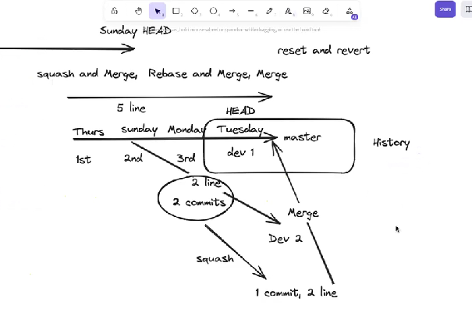

Squash can not recognize which commit is issue

But dump gradually one by one marge with master branch, so its easily we find out issue.

Commit # generate:

Branch undo kore: git checkout –b “my-branch”

Gi reflog: all history,

Git rebase –I HEAD~6 this commit for rebase

After rebase we can commit

git rebase –continue

For undo , at first “git reflog” ai commant ber korbe koto number commit hoyase.

Amend -> squash with other commit.

Easily undo method:

Commit reset: git reset HEAD~1

git checkout –b “my-branch”

commit undo;

using action we can undo everything:

* rebase
* commit
* marge

git reflog: to show everything.

Git checkout -b “test-branch”

Git co master

git rebase –continue

git rebase –I HEAD~6

###############################------------------------#############################

Forking:



git checkout –b “mominul-feature-branch”

git push xyz to mominul-feature-branch

git fetch **jesse** master a different branch, I collect code where from. Now notification is need for new update master branch.

Git checkoutmaster

Git rebasejesse/master

+++++++++++++++++++ EXAMPLE ++++++++++++++++++

Shakib and mominul work on same project: sakib asket mominul, “please marge my branch with your branch”.

Git checkout mominul-feature-branch

Git rebase sakib/sakib-branch

But git remote commit dela shakib name thaka lagbe.

Reset local

Revert